Final Project



**team members:**

- 17309003 (CHO MANKI)

- 17309004 (KIM SEONG HYUN)

- 17309005 (KUM SUNGWON)

- 17309006 (MIN SIWAN)

1. Goal

Because computer technology has grown rapidly, our life has become very stable and comfortable. As a result, the body was less moving, and the weight was getting fatter and the obesity increased.

In order to exercise at home, we have set our goal to make an application with various functions such as how to exercise and record how to exercise.

1. App features

- Check number of movements and time

- Record Daily Weight

- Introduction to various sports positions

- Listening to music

- sign in, sign up

- admin can delete member and see data base and search data.

1. Use cases diagram

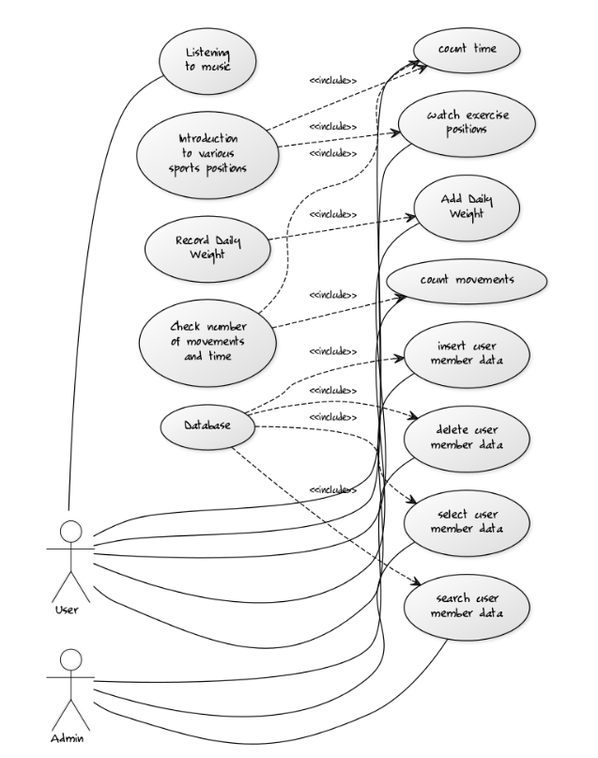

1. Screenshots

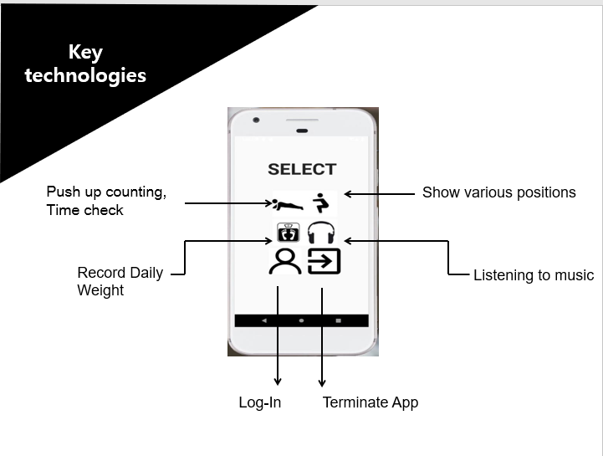

- Check number of movements and time

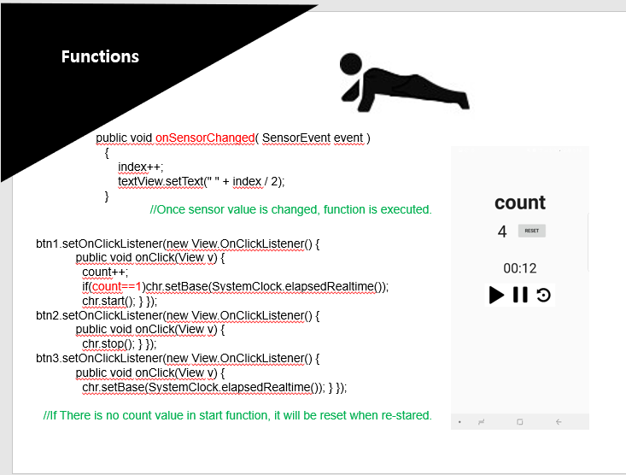

- Introduction to various sports positions

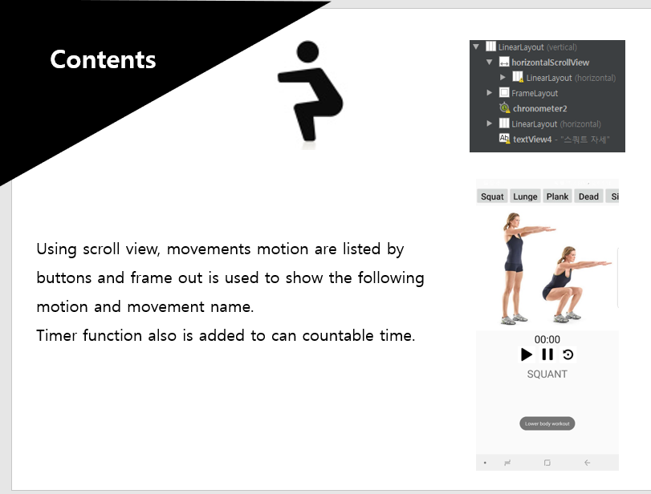

- Record Daily weight

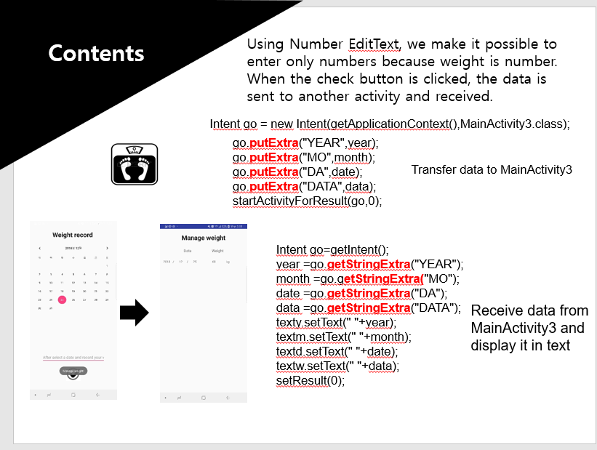

- Listening to music

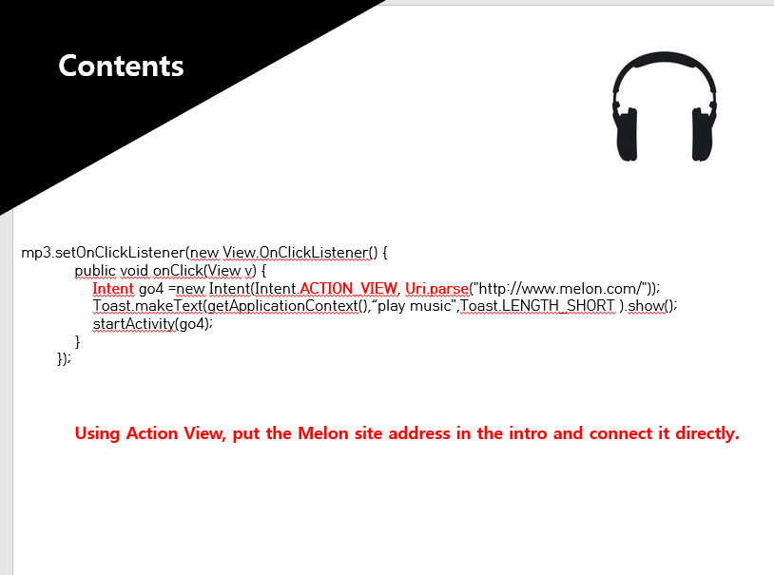

1. Technical Architecture

-Based on Android Studio  
-Java with eclipse  
-Compose Database with phpMyAdmin  
-Web server parsing to get the database